**FULL ADDER**  
  
  
**EXP.NO: 23**  
  
   
**AIM:**  
  
To design and implement the full adder using Logisim  
simulator.  
  
**PROCEDURE:**  
  
1)      Pick and place the necessary gates.  
  
2)      Insert 3 inputs into the canvas.  
  
3)      Connect the inputs to the XOR gate, AND  
gate and OR gate.  
  
4)      Insert 2 outputs into the canvas.  
  
5)      Make the connections using the connecting  
wires.  
  
6)      Verify the truth table.  
  
   
  
**TRUTH TABLE:**  
  
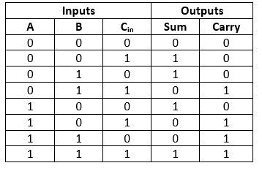

Sum=(A⊕B) ⊕Cin  
  
Carry=A.B+ (A ⊕B)

**OUTPUT:**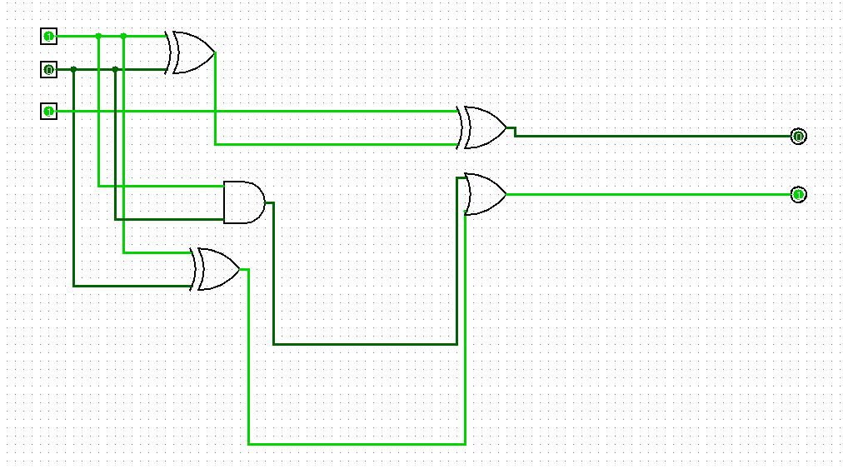

**RESULT:**Thus full adder has been designed and implemented successfully using logisim simulator.